**<https://public.tableau.com/shared/6SQJMGCRB?:display_count=n&:origin=viz_share_link>**

**Stations Map**

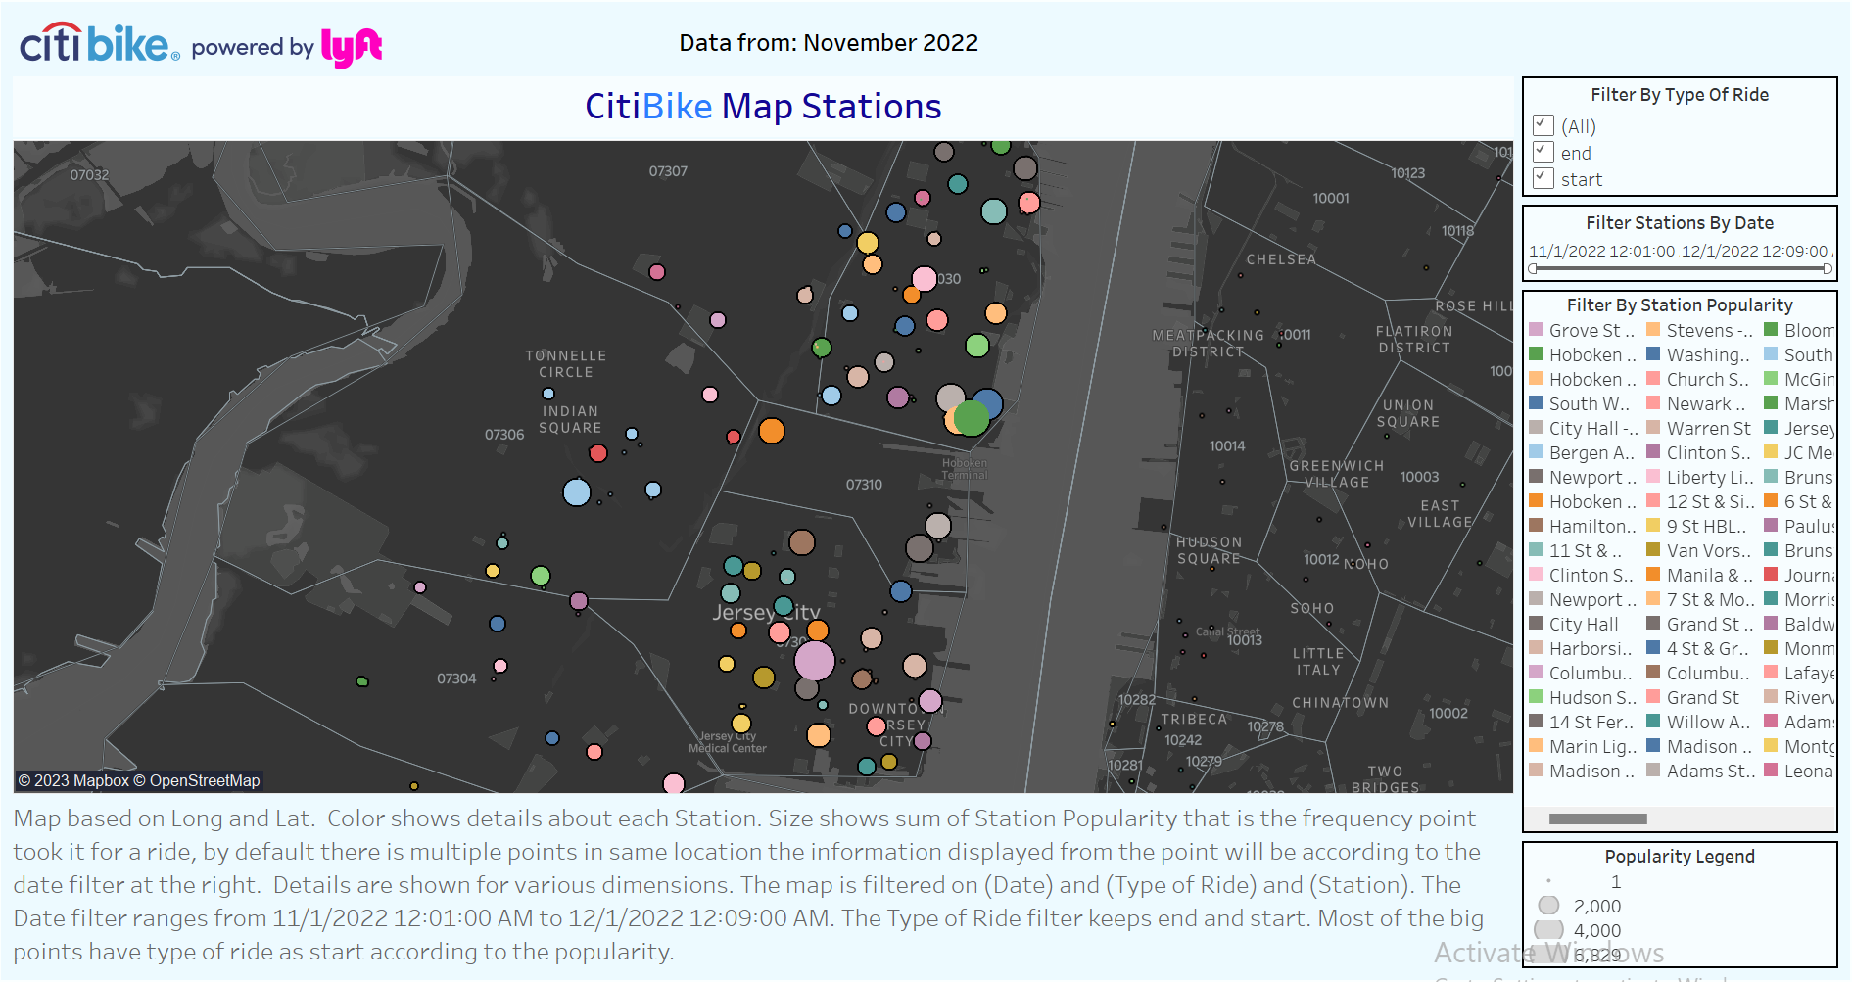

Map of stations provide each station frequency points per individual, its added custom filter options at the right corner that allows to filter by range of date, type of ride and station particular name. Some key points to take in count were that data was transformed in a way that all points could easily be showed this leads to having repeated points in same locations but with different data that can be manipulated with the data filter in order to display the points.

**Bike Usage**

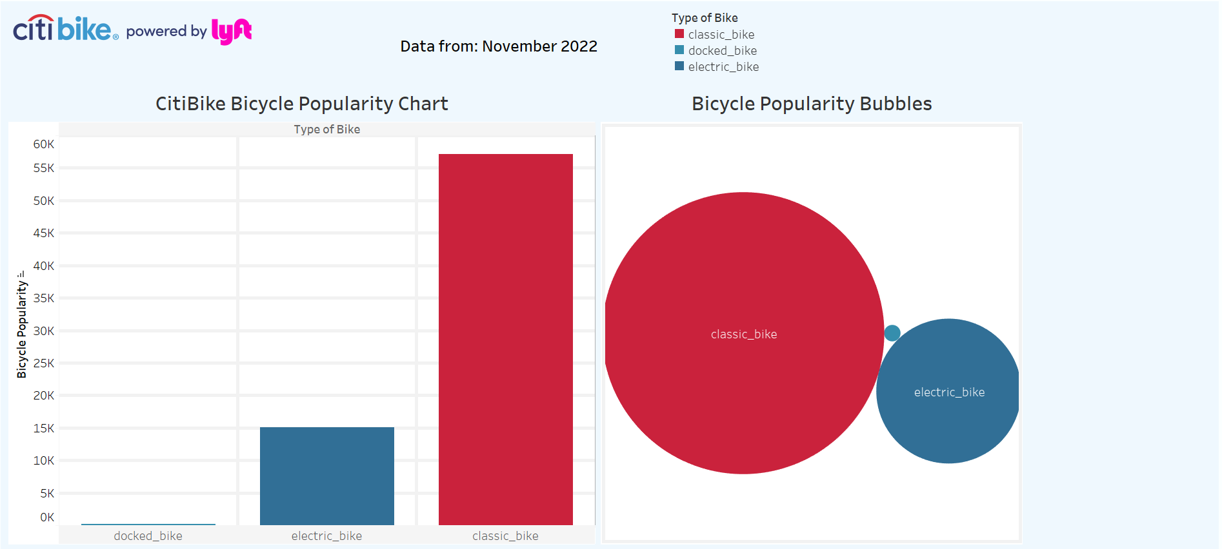

Citibike exploration over popular bikes usage provides a helpful insight represented in two different visualization points that provides a custom filter type of ride to interact within. Some key points that we can clearly see on the data is that most individuals prefer classic bike due its cost and flexibility use where the comparison with the other types makes a very big difference.

**Rides Per Day**

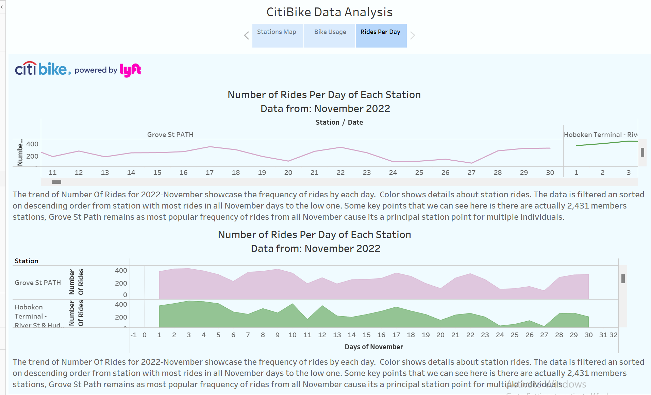

Rides per day analysis was a custom phenomenon implementation that provides very helpful information based on the most popular station days from all November 2022 where the increase of rides growth, each station have its own rows of days and data is grouped by station popularity that allow us to determine the most popular day for the most popular station according to the extracted data.